## Bank Assurance New incentive categories And Calculations.

1. **Bank Assurance Officers**
   1. One policy from new product
   2. Chart of calculation (example)

|  |  |  |  |  |  |  |  |
| --- | --- | --- | --- | --- | --- | --- | --- |
| Product | Min Pol Count | Total Pol Count | Wave Off Count | Income Type | Achievement | FST Com (%) | FYP Com  (%) |
| AA | 1 | 0 | 0 | FST | 80% | 5 | 0 |
| AA | 1 | 0 | 0 | FYP | 80% | 5 | 0 |
| AA | 1 | 0 | 0 | FST | 100% | 5 | 3 |
| AA | 1 | 0 | 0 | FYP | 100% | 0 | 3 |
| Other | 0 | 0 | 0 | FST | 100% | 5 | 3 |

If the Bancassurance officer achieved the Annual FST target with the new product target within the year then from next month he will get the incentive unconditionally for his business.

**Incentive Rate Define Screen**

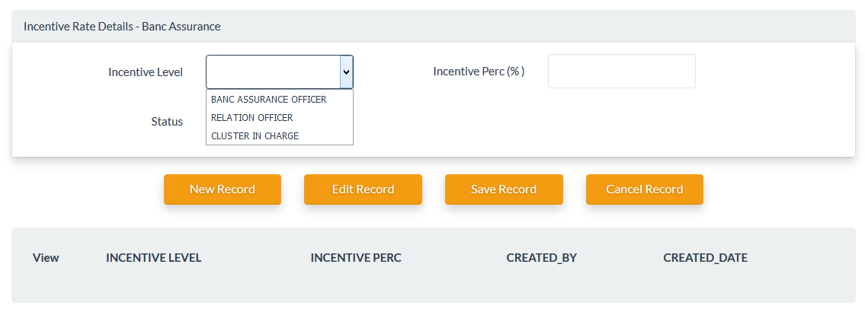

**Rule Define Screen**

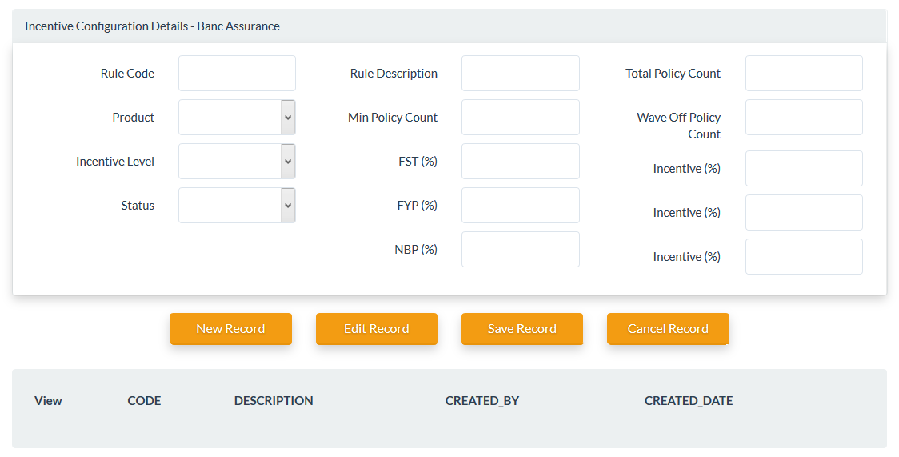

1. **Relationship officers** 
   1. No overriding will be paying for own incentives.
   2. 10% of the attached BAO’s earned incentive.
2. **Cluster in charge officers**
   1. Minimum achievement OF NBP.
   2. All eligibility criteria will be waved off after achieving the FST target and new product target of the attached cluster.
   3. 80% or above will get 0.5%.

**Agent level and hierarchy maintain screen**

While you entering the Banc Assurance officers or Relational officers you can choose the person to whom you are going to report. Through that we may able to extract hierarchy.

Agent Module – Personal tab

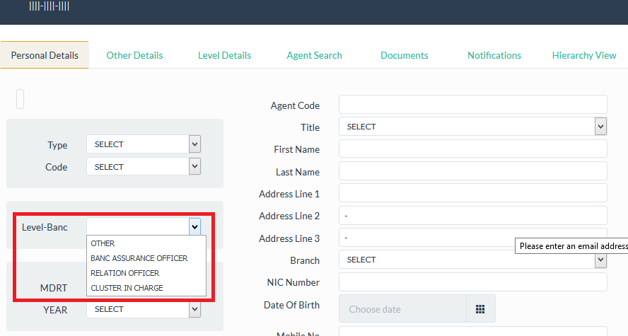

Agent Module – Level tab

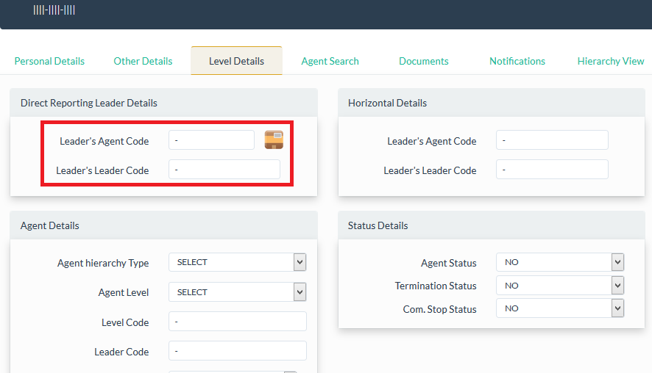

Also please amend the document if something missing or wrong and mentioned the new allowance types with the calculations.

**Please explained below items with in detail then we can design our application accordibgly**

1. **Ranking Allowance**
2. **Non HNB Leads Incentive**